OUTPUT:
SERVER:
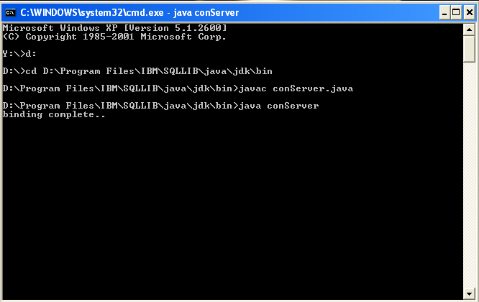

CLIENT:
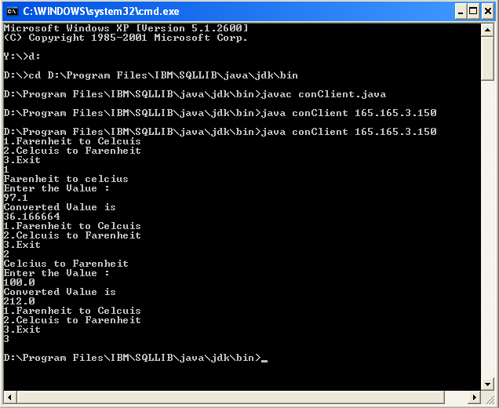

PROGRAM:
//conInt.java
import java.rmi.*;
public interface conInt extends Remote
{
public float c2f(float a) throws RemoteException;
public float f2c(float a) throws RemoteException;
}

//conImpl.java
import java.rmi.*;
import java.rmi.server.*;

public class conImpl extends UnicastRemoteObject implements conInt
{
public conImpl() throws RemoteException
{
super();
}

public float c2f(float c) throws RemoteException
{
return (float)((180.0/100)*c+32);
}

public float f2c(float f) throws RemoteException
{
return (float)((f-32.0)/180.0*100);
}
}

//conServer.java
import java.rmi.*;

public class conServer
{

public static void main(String[] args) throws Exception
{
try{
conImpl srv = new conImpl();

Naming.rebind("conInt",srv);
System.out.println("binding complete..\n");
}catch(Exception e){}
}
}

//conClient.java
import java.rmi.*;
import java.util.*;
public class conClient
{

public static void main(String[] args)
{
int n=0;
try {
conInt service=(conInt)Naming.lookup("rmi://"+args[0]+"/conInt");
while(n==0)
{
System.out.println("1.Farenheit to Celcuis");
System.out.println("2.Celcuis to Farenheit");
System.out.println("3.Exit");
Scanner s=new Scanner(System.in);
int m=s.nextInt();
float a;
switch(m)
{
case 1:
{
System.out.println("Farenheit to celcius");

System.out.println("Enter the Value :");
a=s.nextFloat();
System.out.println("Converted Value is ");
System.out.println(service.f2c(a));
break;
}
case 2:
{
System.out.println("Celcius to Farenheit");
System.out.println("Enter the Value :");
a=s.nextFloat();
System.out.println("Converted Value is ");
System.out.println(service.c2f(a));
break;
}
case 3:
n=1;

}
}

} catch(Exception e ){}

}}

